A Note On Faster SARS-Cov-2 Virus in UK Using Simulation Modelling

December 23, 2020

There are three parts to the reports on the UK virus, VUI 202012/01 (Economist Dec 21, 2020):

1. It is “40% - 70% faster”
2. It is more transmissible
3. Its proportion among positive tests is increasing

The interpretation of these statements, and thinking about the viral mechanisms which to which these effects might be attributed, given the mutations identified in this UK strain, leads to the following points for clarification.

“40 - 70% faster” – what is the measure of this speed, in the quantity that has increased, as well as the time being measured? In particular,

1. Is this the increase in proportion among positive tests [#3 above] over successive measures?
2. Is this a decrease in time to first detection in the lab compared to standard Covid incubations?
3. Is this a decrease in time to first symptoms in test animals compared to standard?
4. Is this a decrease in time found through contact tracing between contact and first appearance of symptoms or first detection of virus?

“more transmissible” – did this relate to speed of transmission or spread? Again, in particular,

1. Did contact tracing permit a time-based relationship between time of contact and first appearance of symptoms among contacts to show that either or both the intervals were smaller, and that more infections per known contact were found?
2. Was there an experimental lab test with animals under controlled conditions of standard spacing, where the introduction of an infection transmitter led to higher numbers being infected in shorter periods of time?

These questions are intriguing, and beyond knowing what was actually done to form the basis of these reports, they led to the general considerations of how the known dynamics of Covid might have changed that could give rise to these kinds of differences.

METHODOLOGY

These questions are intriguing, and led us back to the standard viral temporal dynamics model of Xi, He et al [*Nature Medicine April 2020*], which has viral load and days after infection for incubation, pre-symptomatic transmission, first appearance of symptoms, and viral load tapering to below measurement thresholds in mild cases.

We have incorporated these viral dynamics in the CovidSIMVL agent-based simulation model, which is a stochastic agent-based model which employs the physical analogy of contagion among agents that move in a Pareto-like distribution within a confined space(s). They undergo state changes in accordance to these viral dynamics, where the degree of infection is proportional to the viral load, expressed by the size (Hazard Radius HzR of the agents). An infection of a susceptible by a transmitter may happen after a (simultaneous) move by all agents if they overlap beyond a threshold, with the degree of overlap determining the viral load of infection due to this contagious contact.

The Xi model is based on days, and in CovidSIMVL, each day consists of 24 generations.

CovidSIMVL has a number of parameters that can be set by the user, among which are the base Hazard Radius, the incubation, pre-symptomatic and symptomatic durations, and the mingle factor (which relates to the mobility of the agent in various roles and in different environments). The standard Out-of-Box settings are for a population of 100 agents, with HzR of 5, in a fixed arena of 800x600, a mingle factor of 1, and viral settings as per the Xi model.

The OutOfBox settings result in an R0 of about 2.00 and a time in generations (per move) to termination (no more transmitters) with a single transmitter at initialization, usually with no susceptibles spared.

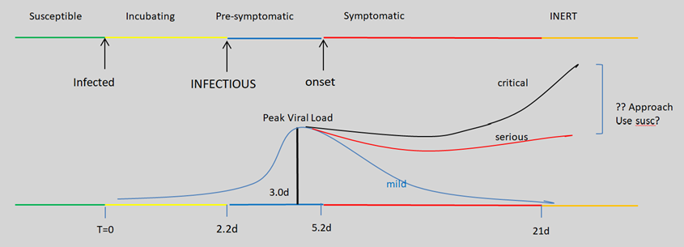

Hypothesis: Increased viral growth rate within agents

We examined the possibility that increases in viral growth within an infected agent causes larger numbers of viral particles to be present, with the same time lines. This led to trials in which the HzR was increased progressively.

We measured the number of generations taken to reach 25 infections, 50 infections and 75 infections, and calculated the speed as #infections/generations – here, generation count is the measure of time, and #infections the standard quantity.

The speeds in the OutOfBox were calculated as controls, and the corresponding speeds were calculated for different HzR.

The “increase of N%” was then calculated by the relationship of (S2 – S1)/S1 as a percentage where S1 and S2 are successive speeds for 25, 50 and 75 infections. R0s were also recorded.

RESULTS

The results of the trials, increasing the Hazard Radius from 5 to 12, produced the following results, as tabulated below.



The top line is the control and represents Out-Of-Box parameters, with a total generation of 1190 cycles (a typical trial) and R0 of 2.02. The number of cycles to 25 infections, 50 infections, 75 infections are found under the headings “Gen to 25” etc.

The velocities with which these markers are attained are found by number/generations. So V.25 is 25/306 = 0.08 for HzR of 5, and V.50 is 50/442 = 0.11, etc. for each of the trial values of HzR.

The Gain in Velocity (“faster than”) is found from comparing the next trial(s) to the baseline HzR=5. Thus, for HzR of 6, the velocity at V.25 is 25/287 = 0.09, and calculating the gain from V.25#HzR5 is

V.25% faster = (V.25#HzR6 – V.25#HzR5)/V.25#HzR5 = (0.09-0.08)/0.08\*100 = 66% = V.25%

R0 is found precisely because the CovidSIMVL simulation sandbox tracks precisely all agents that have infected any susceptible and the number of them, so at the termination of a trial R0 for that synthetic epidemic is the total number of susceptibles infected/number of infecting agents.

We can see that as the HzR increases, the Generation time decreases for increasing value of HzR, and that the velocity gain increases correspondingly. To answer the question: when is the new variant faster than the original by 40-70%, the simulation results vary slightly depending on when the measurements are taken, because there are saturation effects toward the end, as susceptibles diminish in supply. Overall, the fit fot 40-70% is at HzR between 7.5 to 8, compare to the base line value of 5.

The following chart summarizes the above, visually.

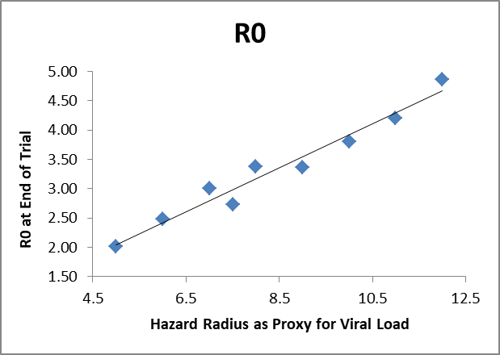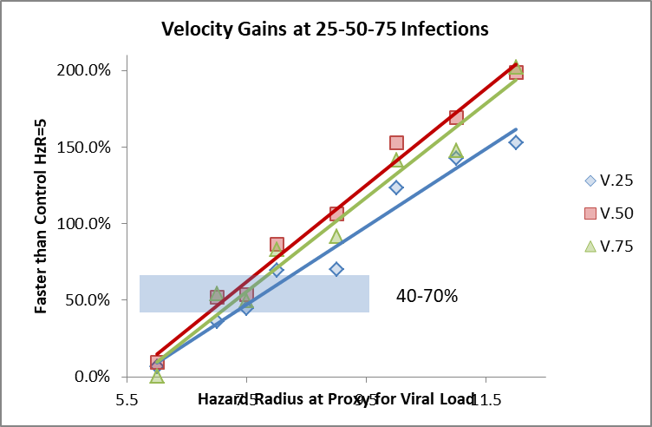

DISCUSSION

CovidSIMVL is a simulation tool which addresses situational analyses. It is not intended to be a predictive tool for IRL (“in real life”) epidemics, but a sandbox in which experiments impossible to conduct IRL can be undertaken. Here, the 70% faster can be achieved if the viral replication in-host is sufficiently large, corresponding to HzR increase from 5 to 7. As 5 is the radius, the volume increase is the cube of the radius given the volume of a sphere being 4/3 x pi x radius^3.

Thus, the viral load from the Xi model would have to increase proportionate to the volume increase from 5 to 7. Given that 5^3 =125 and 7^3 is 346, this implies that the viral replication is 2.5 times the currently prevalent strain of SARS-Cov-2.

A different perspective is that the simulation program uses touch and overlap as the model for viral transmission, so an increase from 5 to 7 in terms of area is just from 25 to 49, which is only a factor of 2.

We tried a number of other combinations of factors to bring about a 70% increase in the speed of infection, as we defined operationally above. For example, we decreased the incubation period of the Xi model (2.9 days) without significant effect, unless the viral replication was increased significantly, as in these reported trials.

To end with a sombre note, if indeed the increased speed is about more rapid transmission in a population, rather than speed of replacement of the older version of the virus, and this higher transmission among persons is due to a higher viral load, then the potential for increased severity of clinical cases is in the grammar, even if not yet expressed in sentences.